Hackerearth question
Count Divisors | Basics of Input/Output & Basic Programming Practice Problems
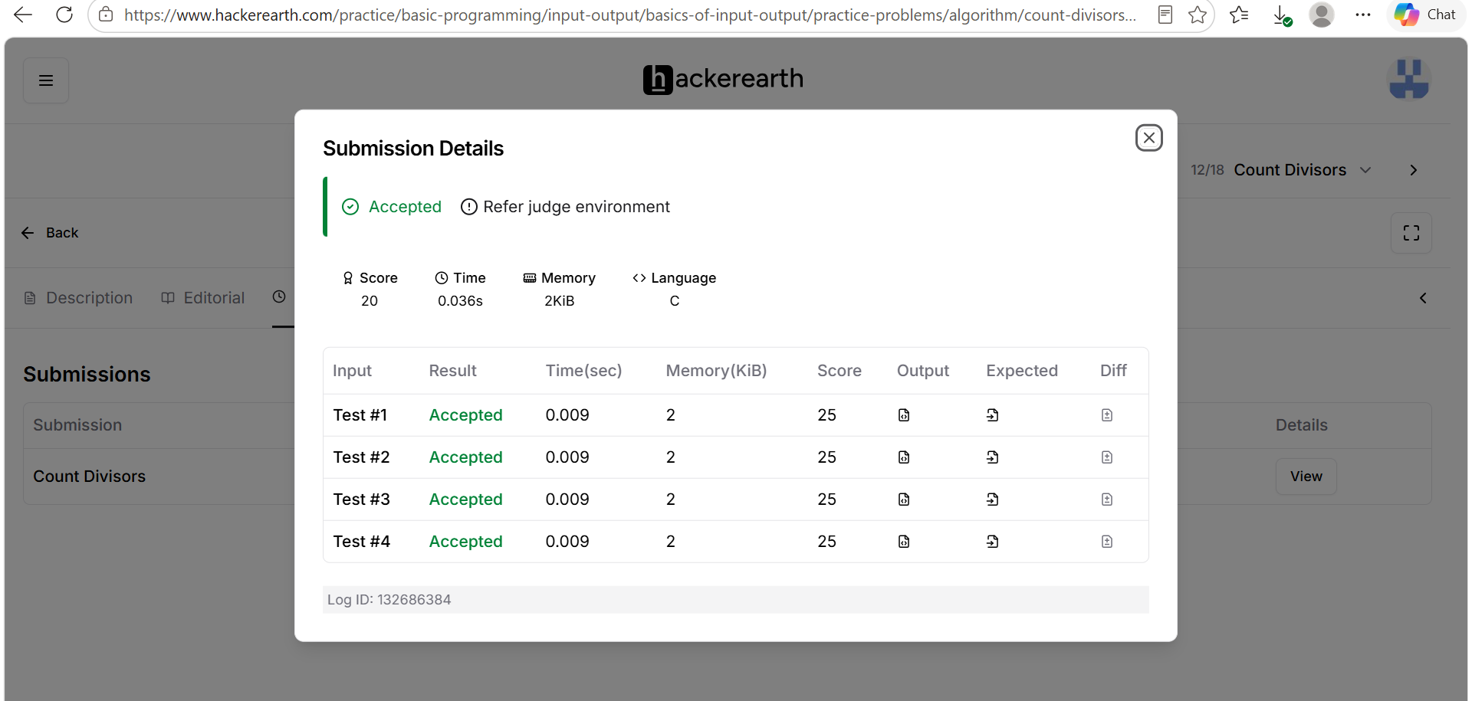
Code
#include <stdio.h>
int main() {
int l, r, k;
// Read the three space-separated integers from the input
if (scanf("%d %d %d", &l, &r, &k) == 3) {
// Compute the count in O(1) time complexity
int count = (r / k) - ((l - 1) / k);
// Print the final result followed by a newline
printf("%d\n", count);
}
return 0;
}

